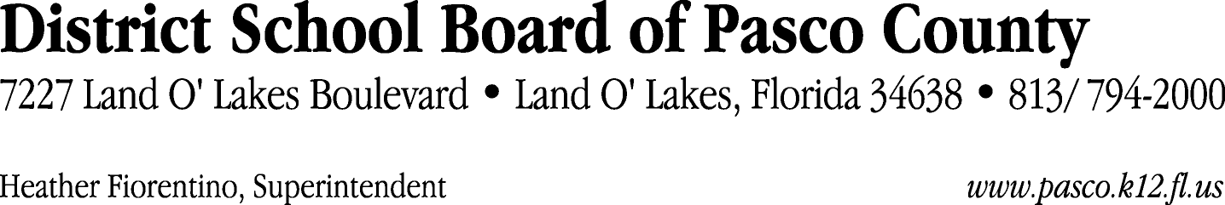

Finance Services Department
813/ 794-2294 Fax: 813/ 794-2266
727/ 774-2294 TDD: 813/ 794-2484
352/ 524-2294
MEMORANDUM

Date: June 8, 2012
To: School Board Members
From: Judith Zollo, Acting Director of Finance Services
Re: Attached Warrant List for June 12, 2012

Please review the current computerized list. These totals include computer generated, handwritten and cancelled checks.

Warrant numbers 844580 through 845008 6,370,977.95

Amounts disbursed in Fund 110 538,436.02
Amounts disbursed in Fund 130 893,459.34
Amounts disbursed in Fund 921 6,839.56
Amounts disbursed in Fund 398 97,900.54
Amounts disbursed in Fund 421 150,589.96
Amounts disbursed in Fund 410 312,573.65
Amounts disbursed in Fund 713 1,827.75
Amounts disbursed in Fund 715 4,019,426.93
Amounts disbursed in Fund 422 12,204.13
Amounts disbursed in Fund 793 50,575.48
Amounts disbursed in Fund 370 46,965.71
Amounts disbursed in Fund 379 2,101.33
Amounts disbursed in Fund 372 475.09
Amounts disbursed in Fund 390 47,670.64
Amounts disbursed in Fund 425 47.22
Amounts disbursed in Fund 432 520.48
Amounts disbursed in Fund 795 293.71
Amounts disbursed in Fund 792 188,970.41
Amounts disbursed in Fund 711 100.00

Confirmation of the approval of the June 12, 2012 warrants will be requested at the July 3, 2012 School Board meeting.

