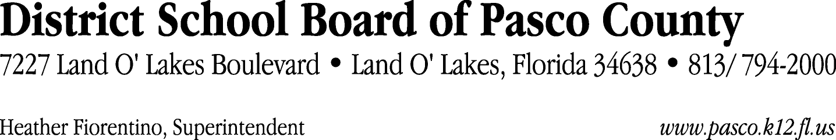

Finance Services Department
813/ 794-2294 Fax: 813/ 794-2266
727/ 774-2294 TDD: 813/ 794-2484
352/ 524-2294
MEMORANDUM

Date: April 30, 2012
To: School Board Members
From: Judith Zollo, Acting Director of Finance Services
Re: Attached Warrant List for April 24, 2012

Please review the current computerized list. These totals include computer generated, handwritten and cancelled checks.

Warrant numbers 841757 through 842128 2,754,396.77

Amounts disbursed in Fund 110 516,478.14
Amounts disbursed in Fund 421 64,183.57
Amounts disbursed in Fund 398 469,563.75
Amounts disbursed in Fund 921 14,010.86
Amounts disbursed in Fund 390 28,133.89
Amounts disbursed in Fund 711 3,266.24
Amounts disbursed in Fund 422 8,598.74
Amounts disbursed in Fund 792 507,580.61
Amounts disbursed in Fund 410 281,582.65
Amounts disbursed in Fund 370 20,926.45
Amounts disbursed in Fund 349 11,796.42
Amounts disbursed in Fund 795 17,296.33
Amounts disbursed in Fund 793 57,083.80
Amounts disbursed in Fund 715 570,149.84
Amounts disbursed in Fund 391 5,783.00
Amounts disbursed in Fund 713 161,828.69
Amounts disbursed in Fund 426 1,524.00
Amounts disbursed in Fund 372 10,854.64
Amounts disbursed in Fund 130 2,555.15
Amounts disbursed in Fund 39C 1,200.00

Confirmation of the approval of the April 24, 2012 warrants will be requested at the May 15, 2012 School Board meeting.

