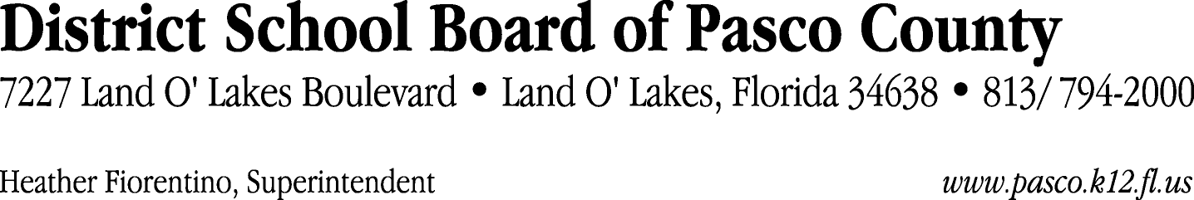

Finance Services Department
813/ 794-2294 Fax: 813/ 794-2266
727/ 774-2294 TDD: 813/ 794-2484
352/ 524-2294
MEMORANDUM

Date: April 18, 2012
To: School Board Members
From: Judith Zollo, Acting Director of Finance Services
Re: Attached Warrant List for April 10, 2012

Please review the current computerized list. These totals include computer generated, handwritten and cancelled checks.

Warrant numbers 840974 through 841401 6,243,577.31

Amounts disbursed in Fund 421 61,647.37
Amounts disbursed in Fund 110 1,198,464.69
Amounts disbursed in Fund 130 994,432.96
Amounts disbursed in Fund 410 370,455.32
Amounts disbursed in Fund 921 1,457.06
Amounts disbursed in Fund 390 55,586.32
Amounts disbursed in Fund 422 5,049.68
Amounts disbursed in Fund 423 2,963.62
Amounts disbursed in Fund 715 3,193,543.49
Amounts disbursed in Fund 372 11,989.47
Amounts disbursed in Fund 792 247,211.43
Amounts disbursed in Fund 793 68,020.77
Amounts disbursed in Fund 713 8,512.50
Amounts disbursed in Fund 370 12,997.50
Amounts disbursed in Fund 398 4,726.74
Amounts disbursed in Fund 434 234.02
Amounts disbursed in Fund 349 1,678.03
Amounts disbursed in Fund 711 17.34
Amounts disbursed in Fund 424 4,089.00
Amounts disbursed in Fund 29C 500.00

Confirmation of the approval of the April 10, 2012 warrants will be requested at the May 1, 2012 School Board meeting.

