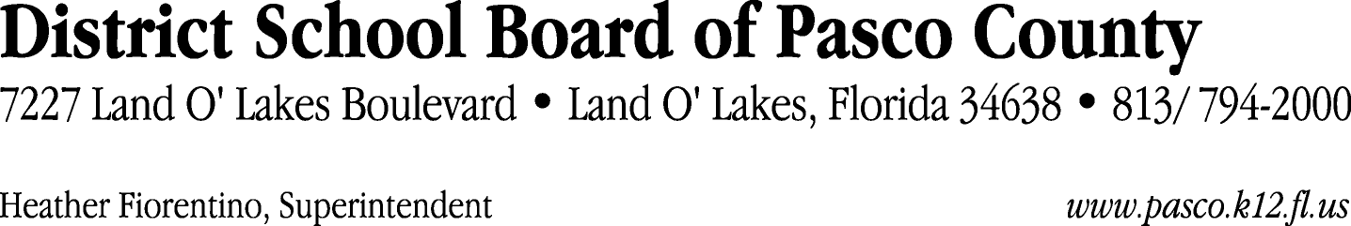

Finance Services Department
813/ 794-2294 Fax: 813/ 794-2266
727/ 774-2294 TDD: 813/ 794-2484
352/ 524-2294
MEMORANDUM

Date: March 26, 2012
To: School Board Members
From: Judith Zollo, Acting Director of Finance Services
Re: Attached Warrant List for March 27, 2012

Please review the current computerized list. These totals include computer generated, handwritten and cancelled checks.

Warrant numbers 840310 through 840736 3,220,774.63

Amounts disbursed in Fund 421 131,035.70
Amounts disbursed in Fund 110 540,975.20
Amounts disbursed in Fund 792 281,226.29
Amounts disbursed in Fund 390 1,104,647.09
Amounts disbursed in Fund 422 4,124.16
Amounts disbursed in Fund 432 47.08
Amounts disbursed in Fund 370 11,580.13
Amounts disbursed in Fund 423 4,475.00
Amounts disbursed in Fund 398 369,144.42
Amounts disbursed in Fund 372 71,724.08
Amounts disbursed in Fund 410 379,502.56
Amounts disbursed in Fund 793 25,237.92
Amounts disbursed in Fund 795 14,816.65
Amounts disbursed in Fund 434 123.50
Amounts disbursed in Fund 379 27,655.08
Amounts disbursed in Fund 715 190,119.70
Amounts disbursed in Fund 921 2,573.24
Amounts disbursed in Fund 713 2,562.50
Amounts disbursed in Fund 794 428.62
Amounts disbursed in Fund 378 58,775.71

Confirmation of the approval of the March 27, 2012 warrants will be requested at the April 17, 2012 School Board meeting.

