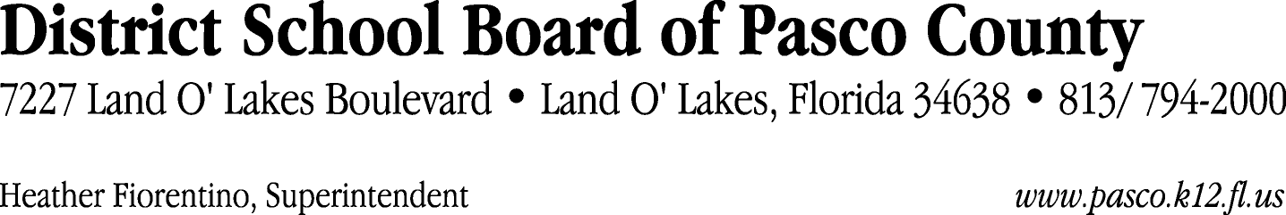

Finance Services Department
813/ 794-2294 Fax: 813/ 794-2266
727/ 774-2294 TDD: 813/ 794-2484
352/ 524-2294
MEMORANDUM

Date: February 9, 2012
To: School Board Members
From: Judith Zollo, Acting Director of Finance Services
Re: Attached Warrant List for February 14, 2012

Please review the current computerized list. These totals include computer generated, handwritten and cancelled checks.

Warrant numbers 837742 through 838084 7,004,908.41

Amounts disbursed in Fund 110 583,360.42
Amounts disbursed in Fund 130 916,389.00
Amounts disbursed in Fund 421 24,371.74
Amounts disbursed in Fund 792 127,788.63
Amounts disbursed in Fund 398 25,885.29
Amounts disbursed in Fund 390 625,998.14
Amounts disbursed in Fund 379 53,486.94
Amounts disbursed in Fund 410 229,265.64
Amounts disbursed in Fund 921 1,199.51
Amounts disbursed in Fund 372 147,849.96
Amounts disbursed in Fund 715 4,048,531.13
Amounts disbursed in Fund 422 3,269.44
Amounts disbursed in Fund 432 4,445.05
Amounts disbursed in Fund 795 2,829.79
Amounts disbursed in Fund 793 32,062.63
Amounts disbursed in Fund 713 10,084.00
Amounts disbursed in Fund 39C 56,736.27
Amounts disbursed in Fund 391 29,933.00
Amounts disbursed in Fund 370 40,107.27
Amounts disbursed in Fund 434 100.70
Amounts disbursed in Fund 349 526.35
Amounts disbursed in Fund 714 1,039.50
Amounts disbursed in Fund 378 39,648.01

Confirmation of the approval of the February 14, 2012 warrants will be requested at the
March 6, 2012 School Board meeting.

