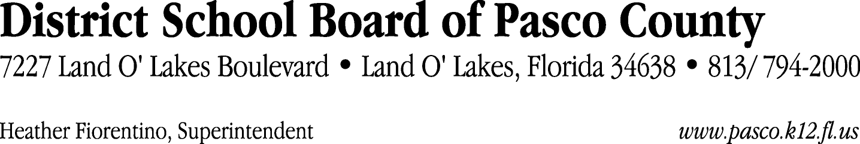

Finance Services Department
813/ 794-2294 Fax: 813/ 794-2266
727/ 774-2294 TDD: 813/ 794-2484
352/ 524-2294
MEMORANDUM

Date: January 26, 2012
To: School Board Members
From: Judith Zollo, Acting Director of Finance Services
Re: Attached Warrant List for January 31, 2012

Please review the current computerized list. These totals include computer generated, handwritten and cancelled checks.

Warrant numbers 836977 through 837317 7,093,644.98

Amounts disbursed in Fund 421 463,003.97
Amounts disbursed in Fund 110 495,096.33
Amounts disbursed in Fund 410 76,608.25
Amounts disbursed in Fund 398 75,171.53
Amounts disbursed in Fund 390 362,726.21
Amounts disbursed in Fund 379 465,574.56
Amounts disbursed in Fund 370 431,131.42
Amounts disbursed in Fund 422 1,521.77
Amounts disbursed in Fund 349 578.00
Amounts disbursed in Fund 921 4,842.21
Amounts disbursed in Fund 715 3,644,193.50
Amounts disbursed in Fund 372 67,615.32
Amounts disbursed in Fund 432 748.58
Amounts disbursed in Fund 792 160,102.54
Amounts disbursed in Fund 793 15,658.84
Amounts disbursed in Fund 713 5,824.70
Amounts disbursed in Fund 391 28,353.65
Amounts disbursed in Fund 39C 587,761.26
Amounts disbursed in Fund 29A 1,650.00
Amounts disbursed in Fund 29B 150.00
Amounts disbursed in Fund 29C 2,150.00
Amounts disbursed in Fund 291 150.00
Amounts disbursed in Fund 292 150.00
Amounts disbursed in Fund 293 500.00
Amounts disbursed in Fund 294 150.00
Amounts disbursed in Fund 296 150.00
Amounts disbursed in Fund 298 150.00
Amounts disbursed in Fund 299 150.00
Amounts disbursed in Fund 434 177,000.00
Amounts disbursed in Fund 795 20,932.34
Amounts disbursed in Fund 341 3,850.00

Confirmation of the approval of the January 31, 2012 warrants will be requested at the February 21, 2012 School Board meeting.

