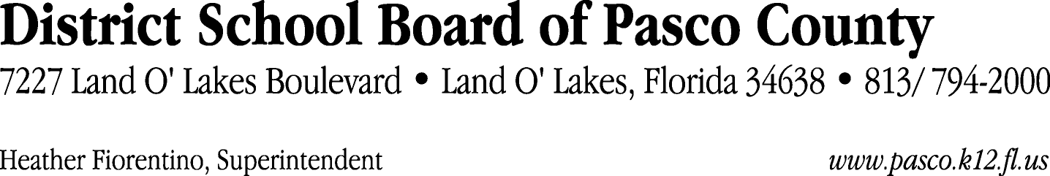

Finance Services Department
813/ 794-2294 Fax: 813/ 794-2266
727/ 774-2294 TDD: 813/ 794-2484
352/ 524-2294
MEMORANDUM

Date: January 24, 2012
To: School Board Members
From: Judith Zollo, Acting Director of Finance Services
Re: Attached Warrant List for January 24, 2012

Please review the current computerized list. These totals include computer generated, handwritten and cancelled checks.

Warrant numbers 836830 through 836971 812,168.41

Amounts disbursed in Fund 410 21,594.08
Amounts disbursed in Fund 110 721,264.63
Amounts disbursed in Fund 421 45,709.35
Amounts disbursed in Fund 422 7,291.10
Amounts disbursed in Fund 714 261.54
Amounts disbursed in Fund 140 2,265.78
Amounts disbursed in Fund 921 9,310.76
Amounts disbursed in Fund 434 392.03
Amounts disbursed in Fund 432 344.28
Amounts disbursed in Fund 424 157.15
Amounts disbursed in Fund 792 231.03
Amounts disbursed in Fund 425 133.19
Amounts disbursed in Fund 711 1,398.28
Amounts disbursed in Fund 713 621.53
Amounts disbursed in Fund 130 1,165.48
Amounts disbursed in Fund 795 28.20

Confirmation of the approval of the January 24, 2012 warrants will be requested at the February 7, 2012 School Board meeting.

