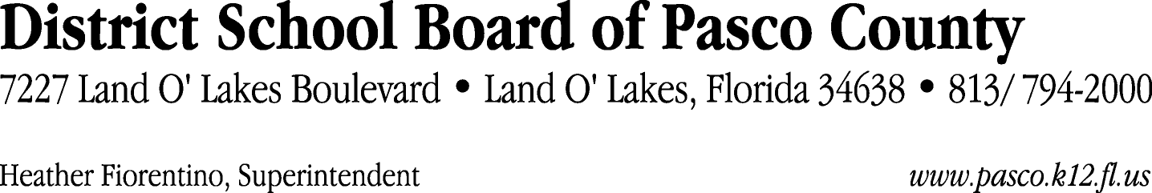

Finance Services Department
813/ 794-2294 Fax: 813/ 794-2266
727/ 774-2294 TDD: 813/ 794-2484
352/ 524-2294
MEMORANDUM

Date: January 19, 2012
To: School Board Members
From: Judith Zollo, Acting Director of Finance Services
Re: Attached Warrant List for January 24, 2012

Please review the current computerized list. These totals include computer generated, handwritten and cancelled checks.

Warrant numbers 836472 through 836824 2,841,201.26

Amounts disbursed in Fund 110 493,503.02
Amounts disbursed in Fund 421 318,465.13
Amounts disbursed in Fund 792 513,351.41
Amounts disbursed in Fund 921 2,866.46
Amounts disbursed in Fund 398 26,232.46
Amounts disbursed in Fund 422 18,723.72
Amounts disbursed in Fund 370 523,752.72
Amounts disbursed in Fund 349 14,818.61
Amounts disbursed in Fund 379 142,125.60
Amounts disbursed in Fund 372 174,430.15
Amounts disbursed in Fund 410 93,582.45
Amounts disbursed in Fund 298 1,748.72
Amounts disbursed in Fund 390 8,284.17
Amounts disbursed in Fund 795 3,955.28
Amounts disbursed in Fund 793 136,607.13
Amounts disbursed in Fund 715 322,737.68
Amounts disbursed in Fund 713 40,675.90
Amounts disbursed in Fund 340 4,890.81
Amounts disbursed in Fund 711 138.70
Amounts disbursed in Fund 434 181.14
Amounts disbursed in Fund 821 130.00

Confirmation of the approval of the January 24, 2012 warrants will be requested at the February 7, 2012 School Board meeting.

