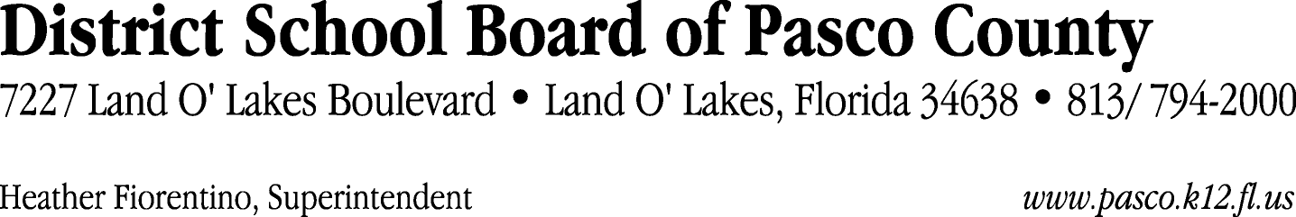

Finance Services Department
813/ 794-2294 Fax: 813/ 794-2266
727/ 774-2294 TDD: 813/ 794-2484
352/ 524-2294
MEMORANDUM

Date: January 9, 2012
To: School Board Members
From: Judith Zollo, Acting Director of Finance Services
Re: Attached Warrant List for January 10, 2012

Please review the current computerized list. These totals include computer generated, handwritten and cancelled checks.

Warrant numbers 836057 through 836230 1,509,655.38

Amounts disbursed in Fund 110 276,567.33
Amounts disbursed in Fund 130 920,864.70
Amounts disbursed in Fund 421 26,973.06
Amounts disbursed in Fund 422 919.00
Amounts disbursed in Fund 921 196.79
Amounts disbursed in Fund 410 160,406.18
Amounts disbursed in Fund 793 16,181.86
Amounts disbursed in Fund 434 155.42
Amounts disbursed in Fund 715 46.00
Amounts disbursed in Fund 372 6,573.22
Amounts disbursed in Fund 713 9,050.32
Amounts disbursed in Fund 821 37.50
Amounts disbursed in Fund 792 91,399.01
Amounts disbursed in Fund 390 284.99

Confirmation of the approval of the January 10, 2012 warrants will be requested at the February 7, 2012 School Board meeting.

