Teachers (and other School Staff) - Acorn User Guide

Logging in:
Go to https://pos.rycor.net/login/pasco
Login using your email (excluding @pasco.k12.fl.us)

Recording a payment:
- Confirm that the school listed at the top of the page is the school where payments are being collected.
- Search for students using Student ID or name.
- Select box for Student making payment.
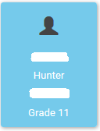
- A smaller box for this student will open on top of the student boxes, select this smaller box.
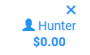
- To collect fees assessed to the student, select the Fees Tab.
  - Note: Fees previously paid will show as paid on the bottom of this screen.
- To select individual fees, select the next to the fee.
- To add all fees, select the 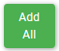 button.
- Added fees will appear in the cart to the right of the screen.
- To add Other items, select the Other Items Tab.
- Selecting the individual items will add them to the cart.
- Additional students can be added to one transaction by repeating steps 2-10. Please note that both Fees and Other Items are tied to the student selected at the time the item is added to the cart.

- Once all items to be paid are added, select the Pay button on the right at the top.
  - If paying less than the full amount, enter the amount in the amount field.
- Next, select the method of payment:
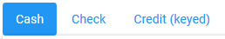
(Continued)
- If accepting a Cash payment, simply select Pay at the bottom.
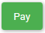

If accepting a Check payment, enter Name (Payer name on check) and Check No. before selecting Pay at the Bottom.

If accepting a Credit Card payment, enter or have parent enter Name on Card, Card Number, Expiration Date and CVV code before selecting Pay
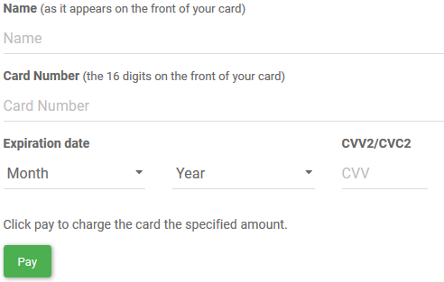
- Once payment is completed, a receipt will load on the page.
- From here, select 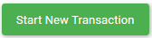to begin taking the next student payment.

Creating Batch Report and submitting funds

Once all student payments are recorded, a Batch Report needs to be created to send to the school Bookkeeper with the money collected instead of the Monies Collected Form.

- Select the to the left of the school name.
- Select . Your current batch will show with the date the first payment in that batch was recorded and will not show a close date.
- To review the batch, select the 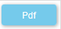option. This will generate a pdf report to use to verify the funds collected match the batch total. The report is grouped between cash and checks showing a total of each.
  - Note: Credit card payments taken do not show in this batch. Credit card payments are batched separately as there is no review required by the teacher.
- Once the report is verified to the funds collected,
  - To email the report, close the report window and select 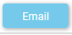 from the prior screen. Enter your email address and your bookkeeper’s email address separated by a semicolon “;”. If the report is emailed to your bookkeeper, write the batch number on the envelope with the funds when given to the bookkeeper or placed in the overnight cash safe.
  - Alternatively, print the report, sign and date it and include with the funds provided to the bookkeeper or placed in the overnight cash safe.

Creating an Account for a new student
- Confirm that the school listed at the top of the page is the school where payments are being collected.
- Select the to the left of the school name.
- Select .
- Fill out only the First Name, Last Name, Date of Birth and Grade Fields.
- Select 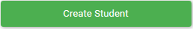.
- School or Grade wide fees for new students will populate on their account upon creation. Other Fees taken, such as course fees, for students created manually in Acorn will be from the Other Items Tab when taking payment.

