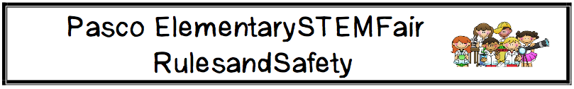

Rules & Regulations:

- The deadline for entries is Friday, March 27, 2015.
- Judging categories assigned based on students’ age by January 1, 2015.
- STEM Fair April 18, 2015 at Thomas E. Weightman Middle School.

Animal Use:
- Special precautions need to be taken if there is ANY experimentation on living animals. The animals may not be subjected to physical or psychological harm. The classroom teacher must approve any animal projects. If there are any questions or concerns please contact Susan McKenna (smckenna@pasco.k12.fl.us).

Project Display and Measurements:
- The backboard and any other items displayed must fit in an area that is 18 inches deep by 36 inches wide. We will be using the cafeteria tables and do not want to create any safety hazards with projects on the floor.

Project Display and Safety:
- The following items are NOT permitted to be displayed at the Pasco Elementary STEM Fair:
  - Any glassware including containers containing liquids. Have ALL students remove any glass items from their displays.
  - Any awards, medals, business cards. Even though these are impressive, they give an unfair advantage over other students.
  - Any sharp items or edges. These can be hazardous to students or others viewing objects.
  - No open flames or anything combustible.
  - Mold regardless if it is in a container may not be present. Only pictures of the mold are allowable.
  - No food either human or animal food.
  - NO ELECTRICITY will be available due to lack of space and safety.

